Portfolio 1 individual exam
[Document subtitle]

[Date]
Rasmus Jonssønn Skramstad
s360619
Oslo Metropolitan University

1 Introduction 2
2 Simpleperf 2
3 Experimental setup 4
4 Performance evaluations 4
4.1 Network tools 5
4.2 Performance metrics 5
4.3 Test case 1: measuring bandwidth with iperf in UDP mode 5
4.3.1 Questions 5
4.3.2 Results 6
4.3.3 Discussion 7
4.4 Test case 2: link latency and throughput 7
4.4.1 Results 7
4.4.2 Discussion 8
4.5 Test case 3: path Latency and throughput 8
4.5.1 Results 8
4.5.2 Discussion 8
4.6 Test case 4: effects of multiplexing and latency 8
4.6.1 Results 8
4.6.2 Discussion 9
4.7 Test case 5: effects of parallel connections 9
4.7.1 Results 9
4.7.2 Discussion 9
5 Conclusions 9
6 References (Optional) 9

Introduction
An introduction should tell the reader why this work is interesting.

It should describe:
- the key topic(s)
- the problem(s) that you are solving
- references to the relevant work (for example: iPerf)
- your approach to the solution
- limitations and outcomes
- how the rest of the document is organized

Today we have the opportunity to operate on people from the other side of the world, this is possible with virtual reality, so a surgeon can sit on the other side of the world while one operates on you. We should then have a fast internet connection so that the video we send is in a such high quality that there is no doubt about what we are doing. Research has shown that better video and network transfer speed could improve the success rate (Pandav et al., 2022). There are also possibilities for self-driving cars that constantly need to know where it is in relation to others. The speed of the network can mean the difference between life and death.

Because of theese facts, I have created a network tool to be able to measure the speed of the network. This tool is called simpleperf and is written in Python 3. The inspiration is taken from another network tool called iPerf which is built on open-source software (SOURCE). Many of the same options can be used in the same way, given that the features are implemented. iPerf supports both TCP and UDP, but my tool currently only supports TCP. There are other differences in maximum speed, this comes from the programming language used. iPerf is written in a compiled language (C), while mine is written in an interpreted language. This is simply because of the overhead needed to interpret the code into a language which a computer can understand and execute, for that reason not supporting very high throughput this is not a large issue. For example, if I run simpleperf for 25 seconds I get a throughput of 1829 megabits per second and a transfer of 5716 megabytes with iPerf I get for 30.5 gigabits per second with a total of 88.7 gigabytes sent. Thus, we can see that iPerf is about 16 times faster than my implementation.

The rest of the document is structured with a deeper explanation of the building blocks of simpleperf, a brief explanation of the experimental setup, other networking tools used to perform performance evaluations, and different test cases. There is also a conclusion and references at the bottom of the document.

Simpleperf
Implementation details of simpleperf. Describe the building blocks of simpleperf and the communication between the server and client.

The very first thing simpleperf does is to check what kind of data a user has entered; if the data is not correct, the user gets an error message, and the program ends. If any client specific flags are not set, the same will happen. The methods for checking the data are invoked by the parser from the library “argparse”. In addition to an error message, the user also receives a help text on how to use the program correctly. The very first thing a user has to do is start a server. I can do this by setting the server flag, if nothing else is specified, preset flags will be set. This would be an IP address set to localhost (127.0.0.1), the port would be set to 8088 and the statistics would be printed out in megabytes.

For checking the port, we are checking that the number is an integer in a range of 1024 and 65,535. If it's not, we will print an error.

For checking the IP address, must be in dotted decimal notation. We are also removing leading zeros in addition we are checking the ranges for the address. The IP address must be in IPv4 standard with decimals. For the format variable of the statistics it must be “B, KB or MB” this format variable will also be used to present the throughput. For example, if we use MB, we will see the throughput in Mbps
After this, the function "start_server" will be called, then the program will try to bind a TCP socket to the addresses that have been set. If the program does not create a socket, it will print an error message. If this is not the case, we then listen for incoming clients. When a client connects, it will then be given a new port, which will be the port for the rest of the session. This is because we want the port to stay open, for other clients that want to connect. We will then start a new thread to handle this. This is done so that other clients do not have to wait for the first one to finish. I have used the threading library to achieve this.
On the new thread, we start a timer for measuring the time it takes to transfer data, in addition we also count the packets we receive. The count of the packets is counted using the built-in method for lengths of variables len(), we can to this because the escape character we send from the client is exactly 1 byte. It is set to be “x\10”. After the package has been counted, we remove the escape character, to make it possible for the client to finish the session if they want. This is to make sure that we have a graceful closing of the client socket. Finally, we print the statistics by calling the function “general_summary()”
For starting clients, we have more flags we can set. The flags you get sets are the IP address for connecting to the server, this needs to be the same as what we set earlier. This is also true for the ports. The client specific arguments are the duration to send data for, else we can set the number of bytes to send. We can also set how we want to print the statistics of the transmission; we can print every set number of seconds or print at the end of the transmission. It is also possible to run clients in parallel, this is made possible by using the same threading library.
To start in client mode, we need to set the client flag. After the client flag is set, we will check that no specific server flags are used. All the arguments are then parsed if all the is all the arguments for the flags are correct and valid, it will then try to start the clients with invoking “start_clients()”. In start clients maybe we'll first print out which port and address we're trying to connect to it will then create a list to keep track of all the live threads. After this it will start x number of clients set by the parallel flag. Then we check if we need to print in interval mode or simply print when all the threads are finished with their transmission.
When the client is trying to connect to a server, we first need to create the socket, then we can try to connect to the server with the ports and address provided. If the parallel flag is set, we will have a custom message to show us which port is used for the socket session. After this we can then start sending data, either for a certain duration or number of bytes. If a number of bytes flag is set, we calculate the total, then we create a variable of that size. For the duration of time flag, we send as much data as possible in the duration set. After we are finished with sending all the bytes. We then sent a “BYE” message to signal to the server that we want to close the connection. After the server receives this message, it will send an acknowledgment of “ACK:BYE”, update the elapsed time then appending the transmission.

Implementation details of every function and class of simpleperf
class Transmission | Class for holding the data for each transmission for server and clients
def print_error(error_message): | Function for printing error messages, to standard error output with formatting
def print_server_listening_port(listening_port): | Prints a formatting line and which port a server is listening on
def check_positive_integer(integer): | Check is the input is a positive number, raises an error if it's not integer are a negative. Returns the integer if valid
def check_port(port): | Checks if the port is an integer between 1024 and 65535. Returns the port (integer) if valid
def check_ipaddress(ip): | Checks if the ip are in dotted decimal notation, and removes leading zeroes. It checks the ranges of the numbers, and if it starts or ends with 0. Returns the same IP-adress (string) without leading zeroes if valid
def check_nbytes(nbytes): | Checks if number of bytes to send is in the correct format using regex, Returns string if valid
parser.parse_args() | Parses the arguments from the user, it calls the check functions to validate the inputs given
def general_summary(server_mode=False): | This function will print the summary of the client or server
def print_total(): | This function prints the total summary of the client or server
def server_handle_client(c_socket, c_addr): | This function is used to handle the client when it joins the server. It will also print the summary and add the transmission to the global variable transmissions
def start_server(): | This function is used to start the server. When a client connects, it will create a new thread to handle the client I.e. server_handle_client.
def client_start_client(): | This function is used to start a single instance of the client, the client will try to connect to a server using TCP sockets with the given port and ip.
def interval_timer(client_treads): | This function is used to print the summary of the client every x seconds while we have clients running
def start_clients(): | This function is used to start the client's
def main(): | This is the main function it starts the server or the client depending on the arguments

Experimental setup

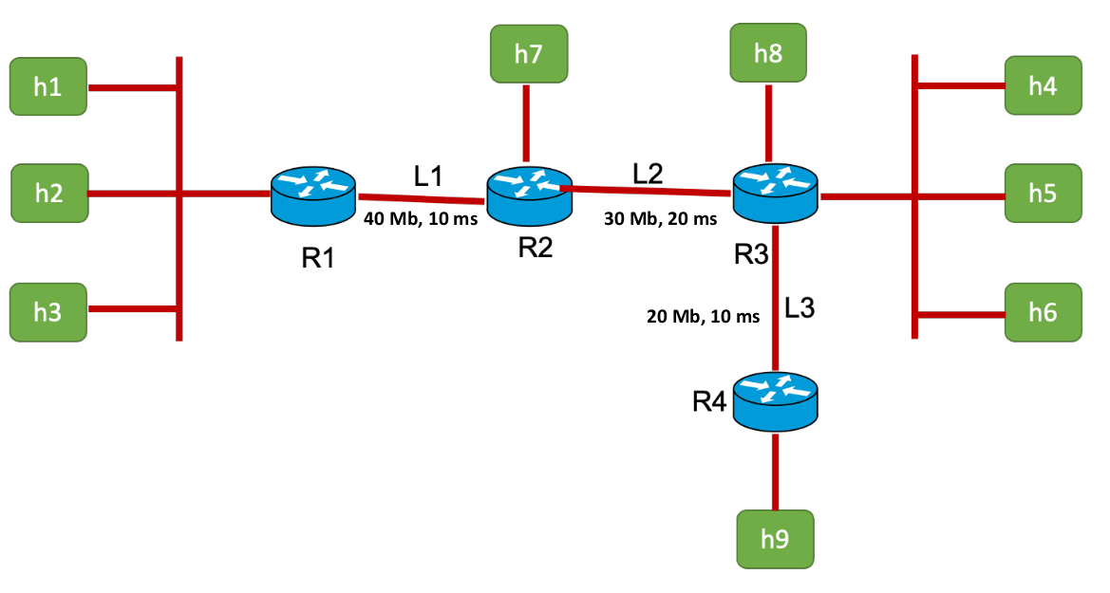Illustration 1 Virtual mininet network

Describe the virtual network/topology that you used to evaluate your simpleperf tool. Feel free to copy my image.

From the illustration given for the virtual network/topology , we can see that 9 hosts connected to 4 routers. Between the routers we have three links L1, L2 and L3. It also seems to also be 2 switches connecting to R1 and R3. This is because we have 3 links connecting to a single point before connecting to the router. The bandwidth and delay of each link are specified.

Performance evaluations
Explain the results why is the rate the way it is.

Network tools
performance metrics that you use to evaluate your simpleperf tool. Explain the tools that you have used in your experiment – iPerf, ping etc.

I have used the following tools to evaluate simpleperf:
- iPerf, a command line network tool to measure network bandwidth using TCP or UDP protocol. It can be used to find the maximum bandwidth between two hosts. One host is acting as a server and the other as a client (iperf, 2023).
- ping, a command line network tool to measure latency in a network. It sends ECHO_REQUEST datagrams using the Internet Control Message Protocol (inetutils, 2023).
- mininet, a command line tool to emulate networks virtually. It can emulate switches, routers, links, hosts. (mininet, 2021)
- openvswitch-testcontroller, a commando line tool to create virtual switches. (Open vSwitch, 2023). It is used in conjunction with mininet for switches.
- gnome-terminal, a terminal emulator for accessing UNIX shell environment (GNOME, 2023).
- Ubuntu (Desktop), a open source desktop operating system (Ubuntu, 2023)

Performance metrics

performance metrics that you use to evaluate your simpleperf tool.
The performance metrics I will use test my simpleperf tool is the throughput. It can measure delay but it is not intended I.e. we can see the elapsed time for a transmission. Loss of packets should not be possible since we are using TCP sockets.

Throughput is calculated using the throughput formula inventory / time. In my simpleperf implementation, I use a time module that uses the returns a float which is a timestamp of the current time since the epoch (I.e. January 1, 1970, 00:00:00). This timestamp might not be as presice on all systems, as some systems dont provide a precision lower than 1 second. (Python Software Foundation, 2023)

Test case 1: measuring bandwidth with iPerf in UDP mode
For this task, I ran three seperate iPerf tests in UDP mode.
SE kapittel 3

Questions

- Which rate (X) would you choose to measure the bandwidth here? Explain your answers.
I choose a high rate of 50 Mbits/s which would bottleneck the network, because I wanted to find the highest possible rate the network could support. If had chosen a lower rate it would be possible that fewer packages would be lost, but if no packages is lost we might not have used the network to its full potential.
- If you are asked to use iPerf in UDP mode to measure the bandwidth where you do not know anything about the network topology, what approach would you take to estimate the bandwidth? Do you think that this approach would be practical? Explain your answers.
If I was able to use iPerf in TCP mode I would use the time flag to measure the bandwidth, because when using TCP we are using a reliable protocol. This is because when using TCP we must deliver data in in complete pieces. When we use iPerf in UDP the default bandwidth is set to 1Mbit/sec (iPerf, 2023). To find measure the bandwidth, we need to try different bandwidths and packet sizes to find the highest bandwidth the network is able to support without dropped packages. I don’t see this approach to be practical because of this trail and error approach.
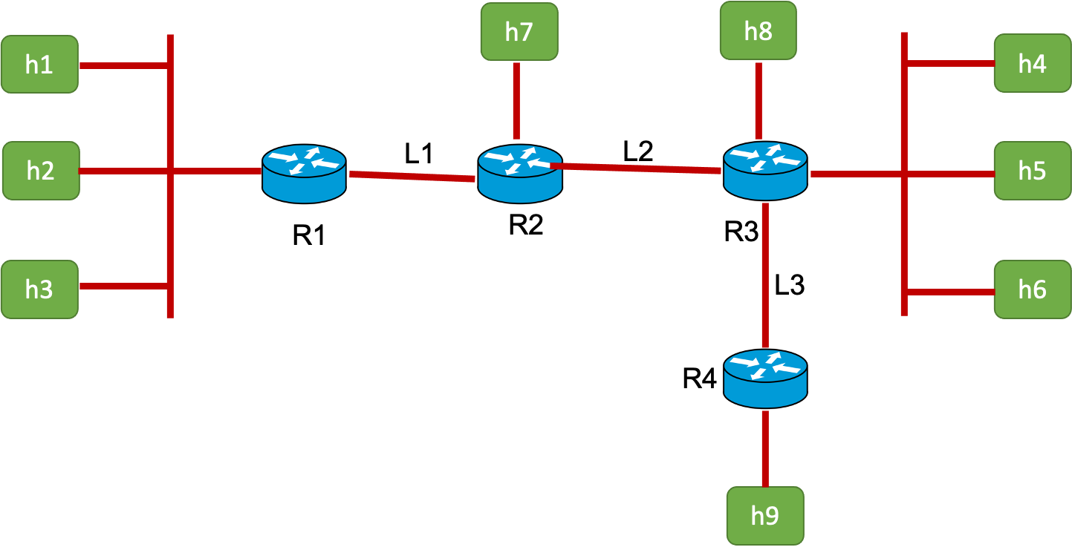

Explain what you are doing.
You can merge both results and discussion sections!

For the test-case we are trying to measure bandwidth using iPerf in UDP mode in a virtual mininet network. To do this we need to first run the python script provided, then we can connect to hosts using “xterm hostname” or running “sudo mnexec -a pid bash”. The process ids can be found if we use the “dump” command in mininet. After this we can run network tools such as ping, iPerf or simpleperf. The network tools a run inside of the mininet network.
Ping is used to measure the roundtrip time for packages send from a host to another. iPerf and simpleperf are used to find measure the maximum bandwidth in networks.

For this test-case we want to measure using a bandwidth set at 50Mbits per second using the bandwidth flag (also -b). By default iPerf is trying to send at the rate we provided in 10 seconds (according to “iPerf -h” ). This bandwidth might be set to high, but since we don’t know the maximum rates we need to test

Results

Client  -  Server | Transferred data | Received  data | Client Throughput | Server  Bandwidth | Jitter | Out of order datagrams | Lost datagrams
h1-h4 | 62.5 MBytes | 34.9 MBytes | 52.4 Mbits/sec | 29.2 Mbits/sec | 0.175 ms | 5 | 19708/44586 (44%)
h1– h9 | 62.5 MBytes | 23.3 MBytes | 52.4 Mbits/sec | 19.4 Mbits/sec | 0.123 ms | 4 | 27985/44587 (63%)
h7-h9 | 62.5 MBytes | 20.8 MBytes | 52.4 Mbits/sec | 17.4 Mbits/sec | 0.215 ms | 29 | 29741/44587 (67%)

Discussion

Explain your results (what you expected vs what you got)

From this result we can see that we have some issues with packet loss and delay fluctuation with the rate that was chosen. To actually find the maximum rate, we need to try with a lower bandwidth. To get more accurate rates, we could try to emulate T

If I the task was to find the maximum supported rate to measure the network, I would run the tests again with a lower bandwidth (the b flag), where the transfer and the received data would be the same. Since we have some issues with packet loss and delay fluctuation. To find the latency, we run new tests using ping.

Test case 2: link latency and throughput
For this task I ran ping to measure the round trip time, with 25 packets each, to check the latency for three links (L1,L2,L3), I did also run simpleperf to mesure the throughput for the links, the duration for sending data was 25 seconds. The reason we wanted to measure this link latency and throughput was to get some basevalues what we could expect when talking through the links in our network.

Kjør iPerf også? Python vs C

Results

Client-Server | Average RTT | Throughput (Client)
R1-R2 | 20.212 ms | 38.13 Mbps
R2-R3 | 40.252 ms | 28.48 Mbps
R3-R4 | 20.215 ms | 19.08 Mbps

We can see that we have the fastest link (L1) between R1 and R2. L2 is faster than L3 but L3 is as low or has the same roundtrip time as L1.

Discussion

Expected round trip time is about expected according to the mininet script / network topology. When using the formula for RTT (2 * propgation delay for the link) we get about the same. The reason we don't get exactly the 20 ms or 40 ms is because of the proccessing delay and queuing delay. The throughput is also what’s expected, the rate is not exacly what the maximum bandwidth can hold.

Explain your results:
• Compare with expected vs reality
• I.e., by looking at the topology what you should get vs your performance evaluations

Test case 3: path Latency and throughput
For this task, I ran ping and simpleperf as the task before, with the same packet count and duration. The main difference is that here we use multiple links and routers to talk to the different hosts. H1 needs to talk to use link 1 and 2 to finaly esablish a connection to H4.

SKRIV OM DELAYS og sush

Results

Client-Server | Average RTT | Throughput (Client)
H1-H4 | 60.595 ms | 28.35 Mbps
H1-H9 | 80.886 ms | 18.01 Mbps
H7-H9 | 60.462 ms | 18.92 Mbps

Discussion

Expected round trip time is about expected according to the mininet script / network topology. The average rtt is the total propgation delay for a link times two. The highest possible bandwidth should be the lowest in the path, this is also true with the expected throughput. The throughput bottleneck for H1 to H4 is L2, and for H1 to H9 it is the L3 link.

Client-Server | Expected RTT | Expected throughput
H1-H4 | 2 (L1 + L2) = ~ 60 ms | ~ 30 Mbps
H1-H9 | 2 (L1 + L2 + L3) = ~ 80 ms | ~ 20 Mbps
H7-H9 | 2 (L2 + L3) = ~ 60 ms | ~ 20 Mbps

Test case 4: effects of multiplexing and latency
For this task, I ran ping and simpleperf as the task before. The difference here is that we need to share the bandwidth with other hosts, because they are simultaneously communicating on the same path. I ran simpleperf and ping separately so that they would not interfere with each other. If I had run these at the same time, the throughput would not have changed to a large extent, but the RTT would have increased considerably.

SKRIV OM HVORFOR VI IKKE HAR DOBBELT OPP AV HOSTS, bottenecks på side 75, multiplexing 170 ish? Mangel på Fairness index? Spesielt case 5

Results

Task 1 (two pairs of hosts)
Client-Server | Average RTT | Throughput (Client)
H1-H4-1 | 60.808 ms | 22.89 Mbps
H2-H5-1 | 60.628 ms | 5.97 Mbps

Task 2 (three pairs of hosts)
Client-Server | Average RTT | Throughput (Client)
H1-H4-2 | 60.820 ms | 12.19 Mbps
H2-H5-2 | 60.814 ms | 8.56 Mbps
H3-H6-2 | 60.856 ms | 8.23 Bps

Task 3 (two pairs of hosts, H7-H9 instead of H2-H5 )
Client-Server | Average RTT | Throughput (Client)
H1-H4-3 | 60.805 ms | 17.73 Mbps
H7-H9-3 | 60.674 ms | 10.85 Mbps

Task 4 (two pairs of hosts, H7-H9 instead of H2-H5 )
Client-Server | Average RTT | Throughput (Client)
H1-H4-4 | 60.773 ms | 28.35 Mbps
H8-H9-4 | 20.324 ms | 19.08 Mbps

Discussion
As expected roundtrips stays the same, this is because ping the ping packages we send are much smaller than the maxium packet size the link is able to transfer. The ping packages are 84 bytes with the Ipv4 header. The expected result if the simpleperf was implmented fairly we should have had an even split of the throughput. In task 1 we can se that the total throughput of the pair (22.89 + 5.97) is under the maximum bandwidth we can have. In an ideal senario where an implimentation of TCP are using a fairness algoritm, the bandwidth should be split equal among the hosts. But for the real world, sessions with smaller RTT are able to access more bandwidth than similar equipped sessions. (Kurose & Ross, 2022, s. 306). We can see the same results in the following tasks that the RTT is not affected in any meaninful degree when running simultaniusly. For tasks 2 the difference can be explained that I started H2-H5-2 later than H3-H5-2.

Task 3

Test case 5: effects of parallel connections
For this task I ran simpleperf with the parallel flag on host h1, for the other hosts h2 and h3 they ran as normal (as the tasks before).

Results

Client-Server | Throughput (Client)
H1-H4-1 | 6.22 Mbps
H1-H4-1B2BVH | 5.65 Mbps
H2-H5 | 9.41 Mbps

Discussion

Conclusions

A concise statement of your work’s important results and their significance. Here you should state any shortcomings/limitations of your work, problems that you failed to address and so on..

References (Optional)

iPerf—iPerf3 and iPerf2 user documentation. (2023, april 2). https://iPerf.fr/iPerf-doc.php#3bandwidth

NOTE:
The report cannot exceed 20 pages, including the list of references. The page format must be A4 with 2 cm margins, single spacing and Arial, Calibri, Times New Roman or similar 11-point font.

